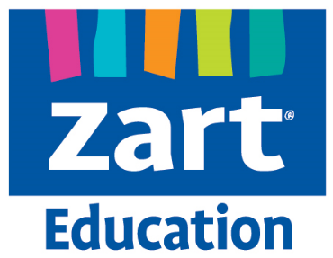
Title | Semi - Abstract Ink Blowing
Learning goals | - Understand the properties of ink  - Identify what abstract art means and looks like
Skills | Students will create a semi abstract ink blown scene using different tones.
Year levels | Junior / Middle Primary
Materials | Ink / Food dye  Straws  Cartridge paper  Small brush  Water pot  Pipette  Brush
Time frame | 1 X 1 hour lesson
Activity breakdown | Students look at different abstract art works. Speak to students about what the word “abstract” means. Show and discuss abstract ink blowing. Students can discuss what they see in the image, describing the shapes that are being formed.  Show students the ink blowing process. Emphasise the importance of using the pipette delicately and using the straw to blow quickly after dropping the ink. Students create their own ink blown shapes.  Students can create a few pages of ink blown shapes. They can then analyse what shapes and forms they can see in the image. What can they see within the image.  Using watered down ink to create different tones, students will then brush over their image to emphasise these forms that they see. By brushing the different tones over the top, they can create more obvious representations of certain forms.
Reflection/ Extension | Reflection  Students can think, pair and share with a partner. Get students in to groups of two to talk about the process of their work and how they came to see certain forms and emphasise these with the brush.  Extension  Students can create some ink blowing works and then swap them with other students. Teachers can also photo copy these and give different students the same image to see the differences or similarities in the finished artworks.

